If pgAdmin is not opening...

In some cases, when students try to open pgAdmin, it throws an error saying it cannot connect to the server. Below is a screenshot of the error:

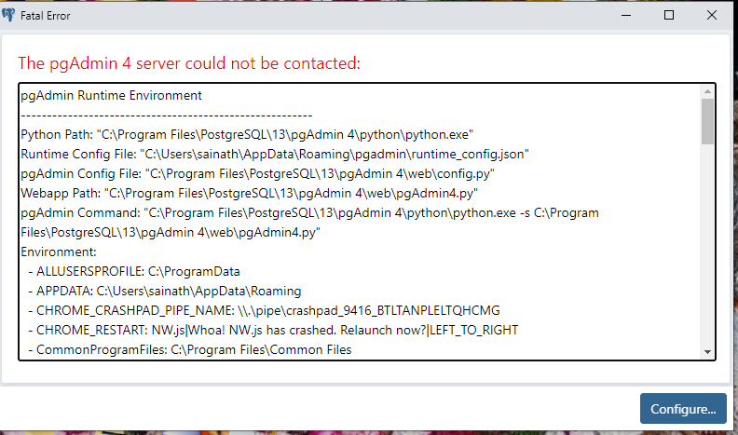

If you are facing this issue, please try out the following possible solutions:

1. If you have upgraded the version of PgAdmin from a previous version, delete the files present in this folder 'C:\Users\%USERNAME%\AppData\Roaming\pgAdmin' and then restart pgadmin

2. Run PgAdmin as administrator by right clicking on pgAdmin 4 icon and selecting "Run As Administrator" option.

3. Try adding the postgres bin path as environment variable. Open postgresql installation directory and look for bin folder. For postgres 12, the location looks like this 'C:\PostgreSQL\10\bin'. To access environment variables: Control Panel > System and security > System or right click on PC, then > Advance system settings > Environment variables > System variables > Path > Edit. Here add the location of this bin location.

If you are still facing the issue, there must be a problem with pgAdmin installation. Please follow the instructions in the following guide to reinstall pgAdmin. This should resolve the issue.

<https://drive.google.com/file/d/1yQZhqvlhkbfVUglFqAph9e4jxjJ-Wwwj/view?usp=sharing>